***SYSTEM DESGIN***

**System Architecture:-**

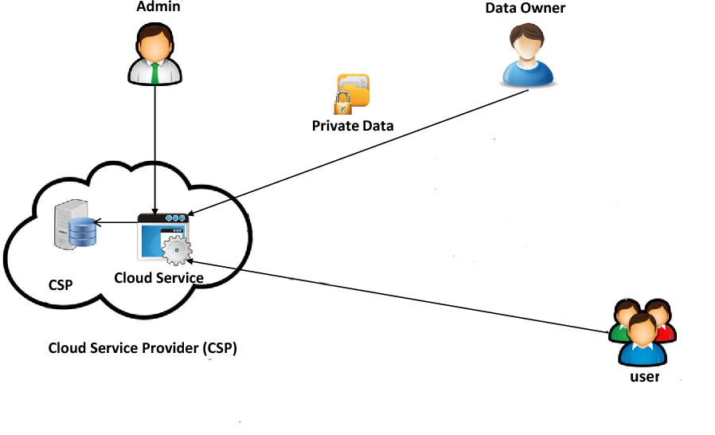

**DATA FLOW DIAGRAM:**

1. The DFD is also called as bubble chart. It is a simple graphical formalism that can be used to represent a system in terms of input data to the system, various processing carried out on this data, and the output data is generated by this system.
2. The data flow diagram (DFD) is one of the most important modeling tools. It is used to model the system components. These components are the system process, the data used by the process, an external entity that interacts with the system and the information flows in the system.
3. DFD shows how the information moves through the system and how it is modified by a series of transformations. It is a graphical technique that depicts information flow and the transformations that are applied as data moves from input to output.
4. DFD is also known as bubble chart. A DFD may be used to represent a system at any level of abstraction. DFD may be partitioned into levels that represent increasing information flow and functional detail.

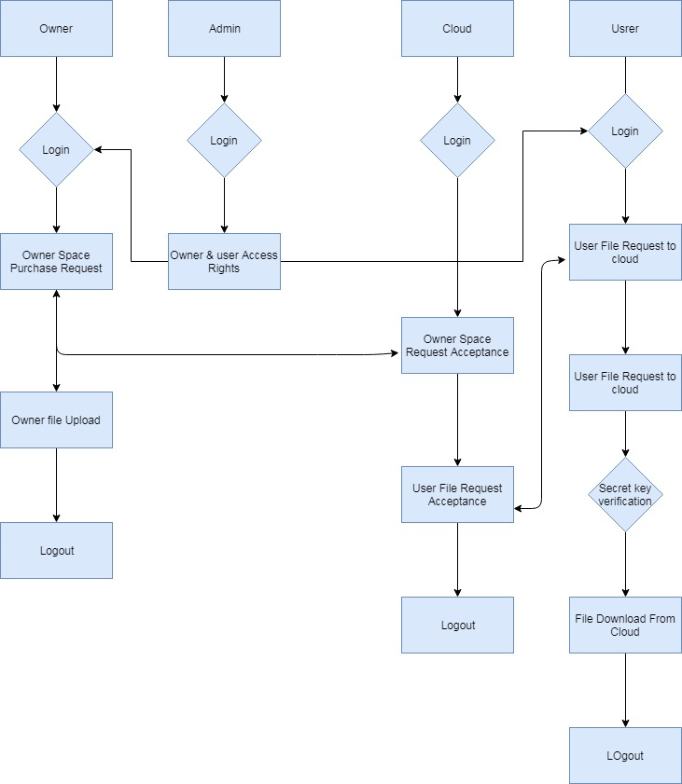

**USE CASE DIAGRAM:**

A use case diagram in the Unified Modeling Language (UML) is a type of behavioral diagram defined by and created from a Use-case analysis. Its purpose is to present a graphical overview of the functionality provided by a system in terms of actors, their goals (represented as use cases), and any dependencies between those use cases. The main purpose of a use case diagram is to show what system functions are performed for which actor. Roles of the actors in the system can be depicted.

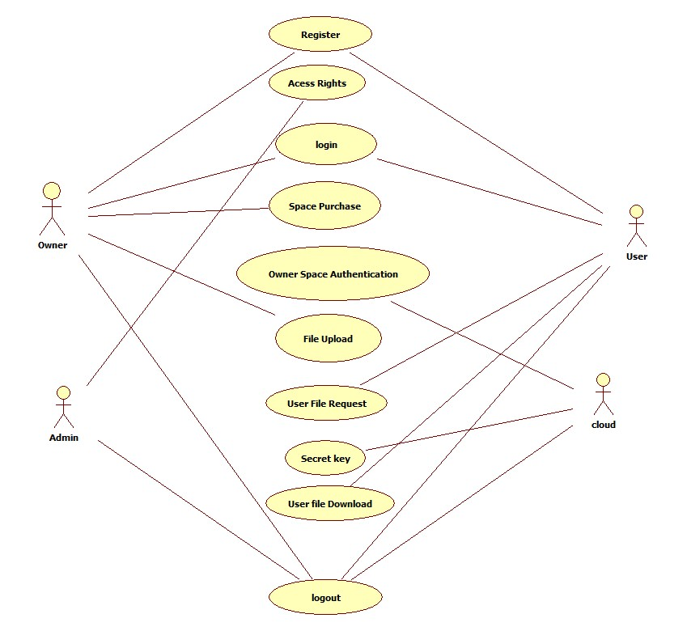

**CLASS DIAGRAM:**

In software engineering, a class diagram in the Unified Modeling Language (UML) is a type of static structure diagram that describes the structure of a system by showing the system's classes, their attributes, operations (or methods), and the relationships among the classes. It explains which class contains information.

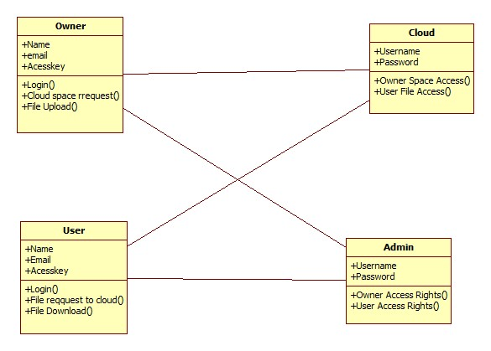

**SEQUENCE DIAGRAM:**

A sequence diagram in Unified Modeling Language (UML) is a kind of interaction diagram that shows how processes operate with one another and in what order. It is a construct of a Message Sequence Chart. Sequence diagrams are sometimes called event diagrams, event scenarios, and timing diagrams.

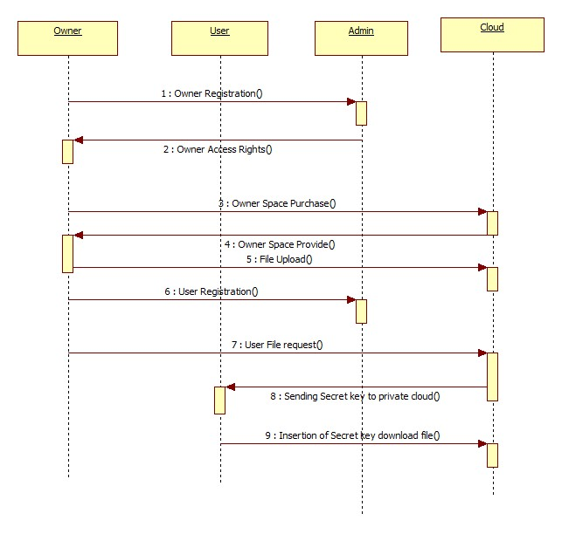

**ACTIVITY DIAGRAM:**

Activity diagrams are graphical representations of workflows of stepwise activities and actions with support for choice, iteration and concurrency. In the Unified Modeling Language, activity diagrams can be used to describe the business and operational step-by-step workflows of components in a system. An activity diagram shows the overall flow of control.

